Topic 3: Electric Circuits

0.3 Specification notice:
In order to develop their practical skills, students should be encouraged to carry out a range of practical experiments related to this topic. Possible experiments include estimating power output of an electric motor, using a digital voltmeter to investigate the output of a potential divider and investigating current/voltage graphs for a filament bulb, thermistor and diode.
Mathematical skills that could be developed in this topic include substituting numerical values into algebraic equations using appropriate units for physical quantities and applying the equation y = mx + c to experimental data.
This topic may be studied using applications that relate to electricity, for example, space technology.

3.Q Exam questions
Why does an increase in temperature increase resistance? | Particles vibrate more frequently (1) therefore collide more frequently with charge carriers (1) preventing them from flowing through so easily
Describe the 6 steps in which filament bulbs have their resistance affected? (Miss Hartley Script)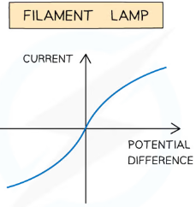 | - As PD increases current increases and electrons begin to move faster with more KE (1)  - Electrons collide with the lattice of positive ions and transfer KE to the lattice of positive ions (LOPI) (1)  - Increases the amplitude of vibrations of LOPI (1)  - Increases the temperature (of the filament) (1)  - Increases the rate of collisions between e and LOPI which increases the resistance (1)  - Less increase for I for the same increase in PD (1)
Explain the shape of the IV graph for the thermistor? (6) (Miss Hartley Script)  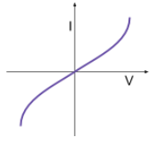 | - As PD increases current increases  - As the current increases the temperature increases (1)  - As the temperature increases more electrons are promoted from the valence band to the conduction band and become free to move (1)  - This increases the charge carrier density (1)  - This causes the current to increase according to I=nAve where A,v and e are constant (1)  - Therefore the resistance must have decreased (1)  - Less increase for I for the same increase in PD (1)

3.31 Understand that electric current is the rate of flow of charged particles and be able to use the equation I=∆Q/∆T

What is electric charge? | The physical property of matter that causes it to experience a force when placed in an electromagnetic field
What is current? | - The rate of flow of charge  - 1A is 1C flowing via a point every second
What is 1 Coulomb? | The charge that flows past a point in one second when there is a current of 1 amp
What is the circuit symbol of a switch? | 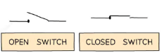
What is the circuit symbol of a cell/battery? | 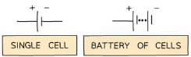
What is the circuit symbol for a diode? | 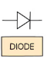
What is the circuit symbol of both a resistor and a variable resistor? | 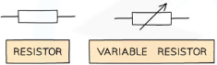  Variable resistor or potentiometer
What is the circuit symbol of Light Emitting Diode (LED) ? | 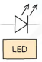
What is the circuit symbol of a lamp? | 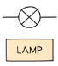
What is the circuit symbol of a fuse? | 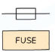
What is the circuit symbol of a voltmeter? | 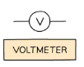
What is the circuit symbol of an ammeter? | 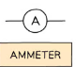  This ideally should have zero resistance
What is the circuit symbol of a thermistor? | 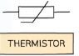
What is the circuit symbol of an Light Dependent resistor (L.D.R) | 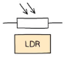
What is conventional current? | The flow of positive charge from the positive terminal of a cell to the negative terminal
What happens to the current, total potential difference and total resistance in a series circuit? | - The current is the same at all points  - The total potential difference of the power supply is shared between components  - The total resistance of two components is the sum of the resistance of each component
What happens to the total current, potential difference and total resistance in a parallel circuit? | - The total current through the whole circuit is the sum of the current through the separate components  - The potential difference across each component is the same  - The total resistance of two resistors is less than the resistance of the smallest individual resistor
What is the equation for two resistors in parallel? | 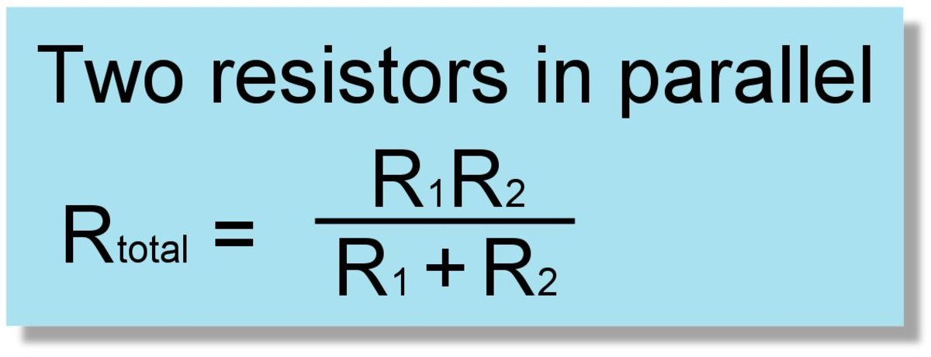
What direction do electrons flow? | They flow from the negative terminal of a cell to the positive terminal
What is the equation for charge using electron charge? | 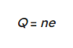  Q=ne
What is the charge on an electron? | 1.6x10⁻¹⁹ C

3.32 Understand how to use the equation V=W/Q

What is voltage | The energy transferred ( or work done) per unit charge
What is the electromotive force equation? (Draw it or write it) | e=W/Q
What is an electron volt? | The change in energy that occurs when a charge of one electron is moved through a p.d of 1V
What is the relationship between 1kWh and kWs? | 1kWh = 3600kWs
What is the Potential difference? | The work done per unit charge
What is resistance? | The voltage required to cause one amp of current to flow

3.33 Understand that resistance is defined by V=IR and that Ohm’s law is a special case when I ∝ V for constant temperature
What is Ohm’s law? | The current through a component is directly proportional to the potential difference across it providing the temperature is constant

3.34 Understand how the distribution of current in a circuit is a consequence of charge conservation
What is Kirchhoff’s First law? | The total current entering any point must be equal to the current leaving the point

3.35 understand how the distribution of potential differences in a circuit is a consequence of energy conservation

What is Kirchhoff’s Second law? | The sum of EMF in any closed loop of the circuit must be equal to the sum of the potential drops
Justify Kirchhoff’s Second Law? | Each charge carrier must transfer all its energy within the circuit and return to the cell with none remaining

3.36 be able to derive the equations for combining resistances in series and parallel using the principles of charge and energy conservation, and be able to use these equations

What can resistance be described as? | How hard it is for current to flow through a component  It being R = V/I means it’s a measure of how much current you get for a particular p.d.
What is resistance caused by? | The repeated collisions between the charge carriers and positive ions.
Complete a proof for the formula of total resistance in a series circuit based on conservation of energy and charge? | V_{T} = V₁ + V₂ due to conservation of energy as V= IR then I_{T}R_{T} = I₁R₁ + I₂R₂ as in series I_{T} = I₁ = I₂ due to conservation of charge therefore R_{T} = R₁ + R₂
Complete a proof for the formula of total resistance in a parallel circuit, based on conservation of energy and charge? | Due to conservation of charge Q_{T}/t = Q₁/t +Q₂/t but I=Q/t therefore I_{T} = I₁ + I₂ but I =V/R so V_{T}/R_{T} = V₁/R₁ + V₂/R₂ in parallel so V_{T} = V₁ = V₂ therefore 1/R_{T} = 1/R₁ + 1/R₂

3.37 be able to use the equations P = VI, W = ItV and be able to derive and use related equations, e.g. P = I²R and P=V²/R

What is power? | The work done per unit time
What is the 3 electrical power equations using V,R and I? | P= VI,  P=I²R,  P=V²/R  Remember twinkle twinkle little star, power equals I squared R
What is the Work done equation using V, I and t? | W=ItV

3.38 understand how to sketch, recognise and interpret current-potential difference graphs for components, including ohmic conductors, filament bulbs, thermistors and diodes

What is the relationship between current and PD of an ohmic conductor and how is it demonstrated on a graph? | Current is directly proportional to potential difference this is shown by a straight line graph through the origin
What does a diode do and how? | It only allow current flow in the forward direction by having a very high resistance in the backwards direction
What applications do diodes have? | To protect components in circuits
Explain the shape of the IV graph of a diode? (3)  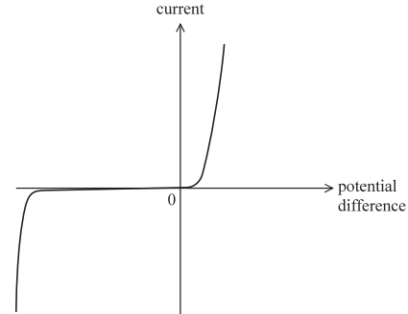 | - It conducts/allows current in one directly only the forwards direction (1)  - In the backwards direction for negative PD the resistance is very high (1)  - At breakdown/large voltage the diode will conduct in the reverse direction (1)  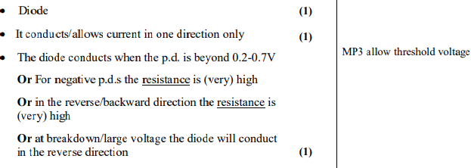
Sketch an IV graph for a diode? | 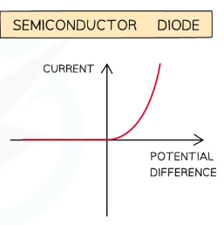
Sketch an IV graph for a bulb/lamp?
Sketch an IV graph for a fixed resistor? | 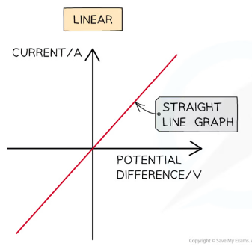
Sketch an IV graph for a thermistor?
Give an example of an ohmic conductor with its current-voltage graph? | A resistor at constant temperature
Sketch an VI graph for a diode? | 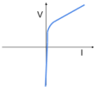
Sketch an VI graph for a bulb/lamp? | 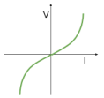
Sketch an VI graph for a fixed resistor? | 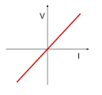
Sketch an VI graph for a thermistor? | 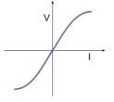
Sketch an Resistance Temperature graph for a thermistor? | 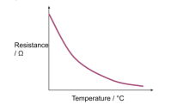
Sketch a Resistance Temperature graph for metallic conductors? | 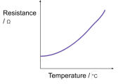
Sketch a Resistance Light intensity (cd) graph for a LDR | 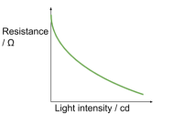

3.39 be able to use the equation R=pl/A resistivity

What can resistance be described as? | How hard it is for current to flow through a component  It being R = V/I means it’s a measure of how much current you get for a particular p.d.
What is resistance caused by? | The repeated collisions between the charge carriers and positive ions.
Why does resistance lead to the material heating up? | Energy is transferred during the collisions between the charge carriers and the positive ions
Why does an increase in temperature increase resistance? | Particles vibrate more frequently (1) therefore collide more frequently with charge carriers (1) preventing them from flowing through so easily
Define Resistivity | Resistivity is a property that describes the extent to which a material opposes the flow of electric current through it
Why is resistivity useful? | It allows resistances of different materials to be compared under the same physical conditions
How does resistance vary with dimensions (length & area (thickness)) and why? | - It increases with length therefore charge carriers have more to flow through  - It decreases with area therefore charge carriers have more options in taking the path of least resistance
What happens to the resistance when the diameter doubles from the resistivity equation?  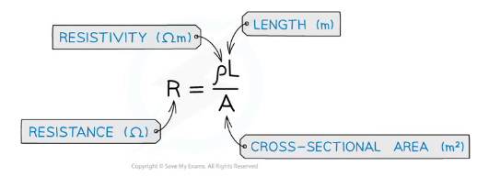 | - It drops by a quarter
What happens to the resistance when the radius doubles from the resistivity equation? | - It drops by half
What is the resistivity equation?
What are the units for resistivity? | Ohmic meters

3.40 CORE PRACTICAL 2: Determine the electrical resistivity of a material.

Describe how to determine a value for resistivity experimentally and explain how to increase the accuracy of the result? (p = resistivity and pi = π) | - Measure diameter of wire with a micrometre  - In three different positions and three orientations  - Calculate a mean average to reduce the effect of a random error  - Calculate cross-area using A=𝜋r²  - Measure the length of the wire with a ruler  - Use a set square to reduce the effect of a parallax error  - Keep the wire under tension to increase accuracy of length  - Use narrow contacts on the wire to increase accuracy and resolution  - Use a voltmeter to measure the p.d in parallel and an ammeter to measure the current in series  - Record data from lengths ranging from 0.20m to 1.20m in 0.20cm intervals  - Calculate R using R=V/I  - Plot graph of R on y-axis and length on x-axis  - As R=pL/A the gradient will be m=p/A therefore p=ma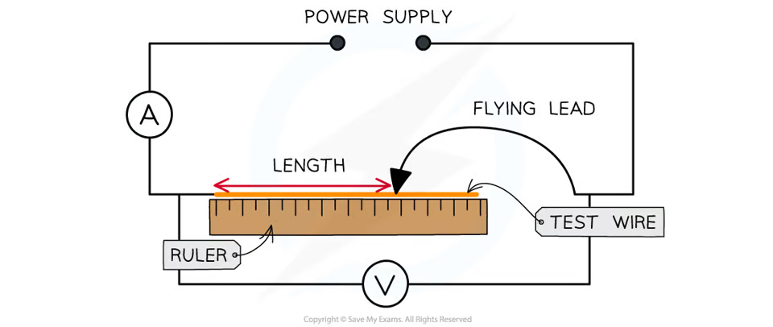

3.41 be able to use I = nqvA to explain the large range of resistivities of different materials

What is the transport equation? | 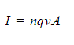Or =I=nAve
What does a negative value for the drift velocity suggest?  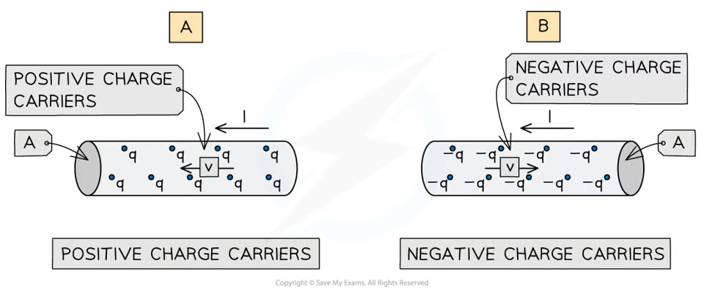 | The current is flowing in the opposite direction to the charge carriers
What is the relationship between v and n in the transport equation and why? | v is inversely proportional to n since the more charge carriers available per unit volume the more the density will slow down their speed through the conductor
What is the relationship between I and n in the transport equation and why? | I is directly proportional to n since a greater n means a greater charge is flowing therefore a larger I
What is the drift velocity? | The mean velocity of the charge carriers travelling through the conductor

3.42 understand how the potential along a uniform current-carrying wire varies with the distance along it

3.43 understand the principles of a potential divider circuit and understand how to calculate potential differences and resistances in such a circuit

What is a potential divider? | A circuit that uses two or more resistors in series to supply a variable p.d.
What is the potential divider equation? | 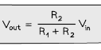
What fact is the potential divider based on and why? And what does this mean? | - P.d is directly proportional to resistance under constant current therefore electrons need more energy to overcome the resistance  - Meaning the resistor with greater resistance will have the greater shared of the p.d

3.44 be able to analyse potential divider circuits where one resistance is variable including thermistors and light-dependent resistors (LDRs)

Explain what happens to the PD across an LDR in series with a fixed resistor when the light intensity increases?  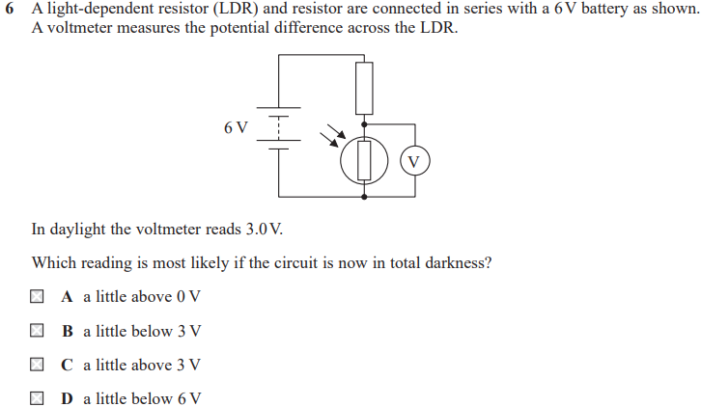 | - As the light intensity increases the resistance of the LDR decreases  - Therefore the total resistance decreases  - _{The current increases}  - As V=IR the PD across the fixed resistor must increase  - As VT=V1+V2 the voltage across the LDR must decrease  _{Answer is C btw}

3.45 know the definition of electromotive force (e.m.f) and understand what is meant by internal resistance and know how to distinguish between e.m.f And terminal potential difference

What is Electromotive Force (EMF)? | The amount of chemical energy converted to electrical energy per unit charge when charge passes through a power supply
What does an ideal voltmeter measure around a cell? | Terminal p.d
How much resistance would an ideal voltmeter have through it? | Infinite
How much resistance would an ideal ammeter have through it? | None
What is the terminal potential difference? | The PD across the terminals of a cell
What is the equation for EMF? (of any variation) 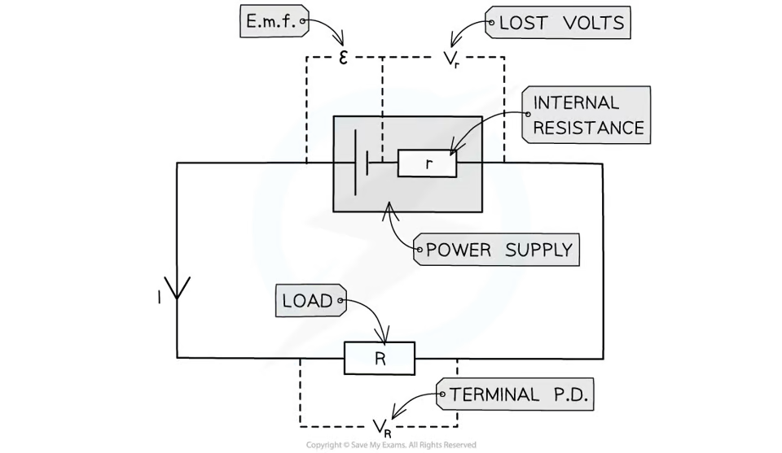 | E=IR+Ir  E=I(R+r)  E=V+v  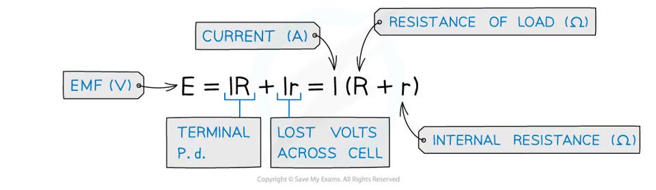

3.46 CORE PRACTICAL 3: Determine the e.m.f. and internal resistance of an electrical cell.

Describe how to find the EMF and internal resistance of a cell experimentally? (E = EMF and r = internal resistance) | - Connect a variable resistor, ammeter and cell in series  - Connect a voltmeter across the variable resistor  - Adjust the variable resistor to 6+ different positions to control the current  - E=V+Ir so V= -rL+ E  - Plot graph of V against I  - r= negative gradient  - E = y-intercept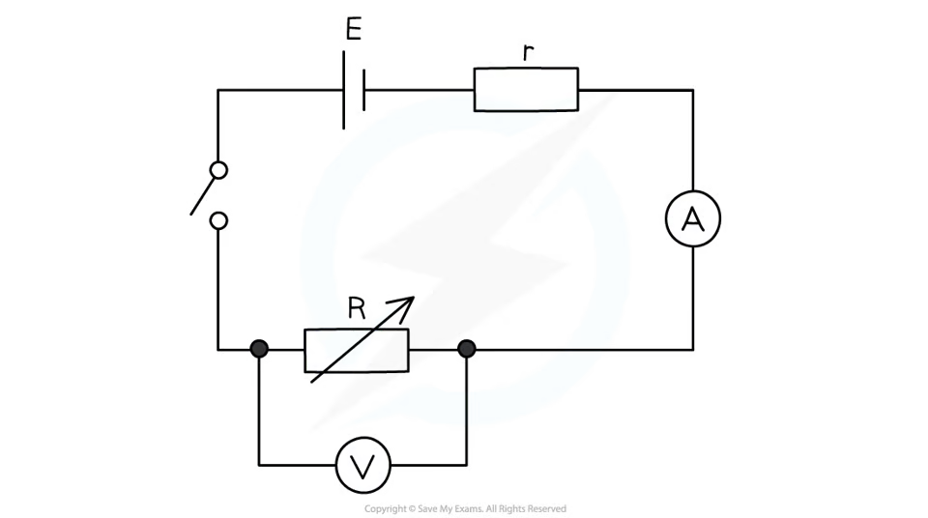

3.47 Understand how changes of resistance with temperature may be modelled in terms of lattice vibrations and number of conduction electrons and understand how to apply this model to metallic conductors and negative temperature coefficient thermistors
Explain the shape of the IV graph for a bulb/lamp? (6) | - As PD increases current increases and electrons begin to move faster with more KE  - Electrons collide with the lattice of positive ions and transfer KE to the lattice of positive ions (LOPI)  - Increases the amplitude of vibrations of LOPI  - Increases the temperature (of the filament)  - Increases the rate of collisions between e and LOPI which increases the resistance  - Less increase for I for the same increase in PD
Explain the shape of the IV graph for the thermistor? (6) (Miss Hartley Script) | - As PD increases current increases  - As the current increases the temperature increases  - As the temperature increases more electrons are promoted from the valence band to the conduction band and become free to move  - This increases the charge carrier density  - This causes the current to increase according to I=nAve where A,v and e are constant  - Therefore the resistance must have decreased  - Less increase for I for the same increase in PD

3.48 Understand how changes of resistance with illumination may be modelled in terms of the number of conduction electrons and understand how to apply this model to LDRs.
Explain how an LDR functions in terms of I=nAve? | - As the light intensity increases electrons absorb photons at a greater rate  - More electrons are promoted from the valence band to the conduction band and become free to move  - This increases the charge carrier density  - This causes the current to increase according to I=nAve where A,v and e are constant  - Therefore the resistance must have decreased as light intensity increased

